Issa Odeh

CPE 400/600: Computer Communication Networks

Instructor: Shamik Sengupta

**HW 3 (Total 20 points)**

**Assigned on: Oct 26, 2020, Due back on: Nov 4, 2020**

**(Submission through WebCampus)**

**Submission format: Microsoft Word or pdf only**

**(file name: firstname_lastname_hw3)**

1. **DHCP experiment [10]**

In order to observe DHCP in action, we’ll perform several DHCP-related commands and capture the DHCP messages exchanged as a result of executing these commands.

1. Begin by opening the Windows Command Prompt application (which can be found in your Accessories folder). Enter “*ipconfig /release*”. The executable for *ipconfig* is in C:\windows\system32. This command releases your current IP address, so that your host’s IP address becomes 0.0.0.0.

2. Start up the Wireshark packet sniffer, as described in the introductory Wireshark lab and begin Wireshark packet capture.

3. Now go back to the Windows Command Prompt and enter “*ipconfig /renew*”. This instructs your host to obtain a network configuration, including a new IP address.

4. Wait until the “*ipconfig /renew*” has terminated. Then enter the same command “*ipconfig /renew*” again.

5. When the second *“ipconfig /renew”* terminates, enter the command “ipconfig/release” to release the previously-allocated IP address to your computer.

6. Finally, enter “*ipconfig /renew*” to again be allocated an IP address for your computer.

7. Stop Wireshark packet capture.

If you are using linux, use the following commands. Note that, the commands may vary depending on linux distributions.

sudo dhclient -v -r (release, -v for verbose)

sudo dhclient -v (renew, -v for verbose)

Now let’s take a look at the resulting Wireshark window. To see only the DHCP packets, you may need to enter into the filter field “bootp”. (DHCP derives from an older protocol called BOOTP. Both BOOTP and DHCP use the same port numbers, 67 and 68.)

[Important Note for experiments: When answering the wireshark questions, you must take screen shots of the appropriate messages and indicate where in the message you’ve found the information that answers the questions.]

Answer the following questions:

1. **[2] Draw a timing datagram illustrating the sequence of the first four-packet Discover/Offer/Request/ACK DHCP exchange between the client and server as captured by wireshark. Provide all relevant information for this DHCP transfer from wireshark into this timing diagram.**

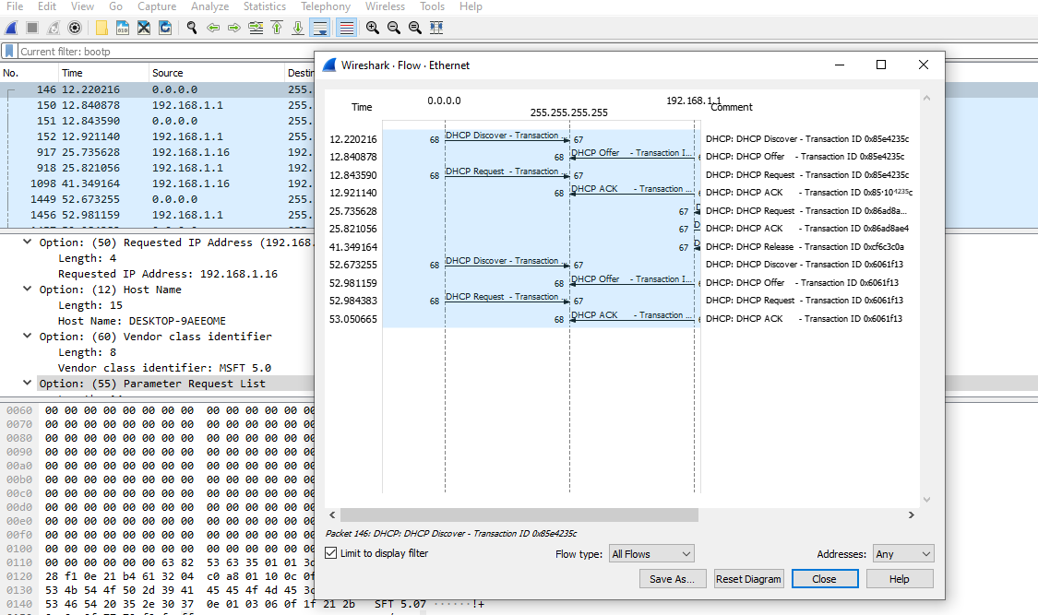

1. **[1] For each packet, indicate the source and destination port numbers. For each of the four DHCP messages (Discover/Offer/Request/ACK DHCP), indicate the source and destination IP addresses that are carried in the encapsulating IP datagram.**

The Discover packet has a source port of 68 and destination port of 67

The Offer packet has a source port of 67 and destination port of 68

The request packet has a source port of 68 and destination port of 67

The ACK packet has a source port of 67 and destination port of 68

Source: 192.168.1.1

Destination: 255.255.255.255

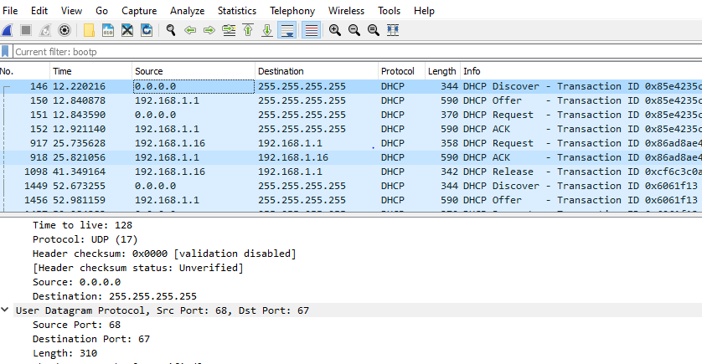

1. **[2] What are the values of the Transaction-ID in each of the first four**

**(Discover/Offer/Request/ACK) DHCP messages?** The Transaction ID in the first four messages: 0x85e4235c

**[1] What is the purpose of the Transaction-ID field?** The transaction ID identifies if a message is part of a set of messages related to one.

1. **[1] What values in the DHCP discover message differentiate this message from the DHCP request message?** The message type value for discover message is 1. But the message type value for request is 3. This is how you can tell the difference between them.
2. **[1] Explain the purpose of the lease time. How long is the lease time in your experiment?** The lease time is the amount of time the user is aloud connection to the router. T=50, L=4. Requested IP Address : 192.168.1.16

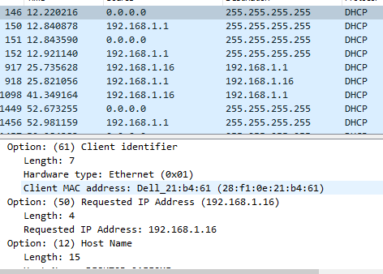

1. **[2] What is the purpose of the DHCP release message? Does the DHCP server issue an acknowledgment of receipt of the client’s DHCP request? What would happen if the client’s DHCP release message is lost?** The DHCP release message tells the DHCP server that the user wants to cancel the ip address offered. The DHCP server will not issue an ack of receipt of the clients DHCP request. If the release message is lost, then the DHCP server retains the ip address until the lease time expires.

**Part2**

1. **[2+3=5]** IP addressing:
2. A software company has 4000 computers. So it needs 4000 IP addresses. Assume class-full addressing. What would be the ideal class from which the company would choose its IP addresses to prevent wastage of IP addresses? How many such networks would the company need for getting 4000 addresses? How many addresses would be wasted? Explain your answers clearly. **Using class B would be the most ideal. Class B uses a 16 bit for a network id. 2^16-2=65534 host address but only 4000ip is needed. So there is wastage of 655534-4000=61534 ip address.**
3. If the company has the flexibility of classless addressing (CIDR addressing), how many bits would be assigned to host part and how many bits assigned to network part? How many addresses would be wasted?

Show your steps to explain your answers.

**4000 IP address is needed. So, we have 2^12=4096**

**4096-2 = 4094 IP address. Then 4094-4000= 94 IP address will be wasted.**

**32-12=20 bit will be used for network id and host id is 12 bits.**

1. **[5]** Execute Dijkstra’s algorithm to find out the shortest path from source F to all other nodes. Show your trace table clearly with each of the shortest paths and distances as discussed in class.

|  |  |  |  |  |  |  |
| --- | --- | --- | --- | --- | --- | --- |
| Step | N’ | A | B | C | D | E |
| 0 | F | ∞ | ∞ | 2,P | ∞ | 3,F |
| 1 | FC | ∞ | 3,C | ∞ | ∞ | 4,C |
| 2 | FCB | 5,B |  |  | 5,B | 3,F |
| 3 | FCBE | 5,B |  |  | 5,B |  |
| 4 | FCBED | 5,B |  |  |  |  |
| 5 | FCBEDA |  |  |  |  |  |

